Driver Score Card - Standard Operating Procedures
Purpose:

The Driver Score Card is a one-page document that covers different measures of driver performance in a user-friendly way. This facilitates coaching and dialogue between Operations Leaders and Drivers. The report can give the driver unbiased, concrete numbers of if their driving performance. The information from the Samsara system provides data that makes it clear if the operator’s performance is satisfactory and if there are opportunities for improvement. Driver Score cards are mainly used on drivers that are new to the driving position or have had opportunities with driver performance such as Hours of Service Violations.
Resources:
Primarily the Samsara system will provide most of the information on the driver score card.
Secondarily, Personal Observations from management team and other teammates such as Logistics via How’s My Driving Reports.
Process:
- Attain list of new Drivers and Back up Drivers from HR. Talent Acquisition & Employee Engagement Manager usually emails out the list of new employees along with their location and job function.
- Look up the Driver’s performance in Samsara. * See notes below on this process
- Fill out the information from Samsara on the Driver Score Card form.
- Email the form to the Driver’s Manager.
- The Manager is to cover the Score Card with the Driver. They are both to sign off on the form and send it back to Logistics and/or the Safety Support Manager.
- The SSM or Logistics Manager files the returned score card on the F: drive.
*Process to look up Driver performance in Samsara
1. On the Samsara home page, look at the left side of the screen and click on the word Safety.
2. Scroll down on the safety page to Driver performance and click on the underlined words “View Report”.
3. On the driver performance report, type in the name of the driver you want to view in the box that states, “Search Drivers”.
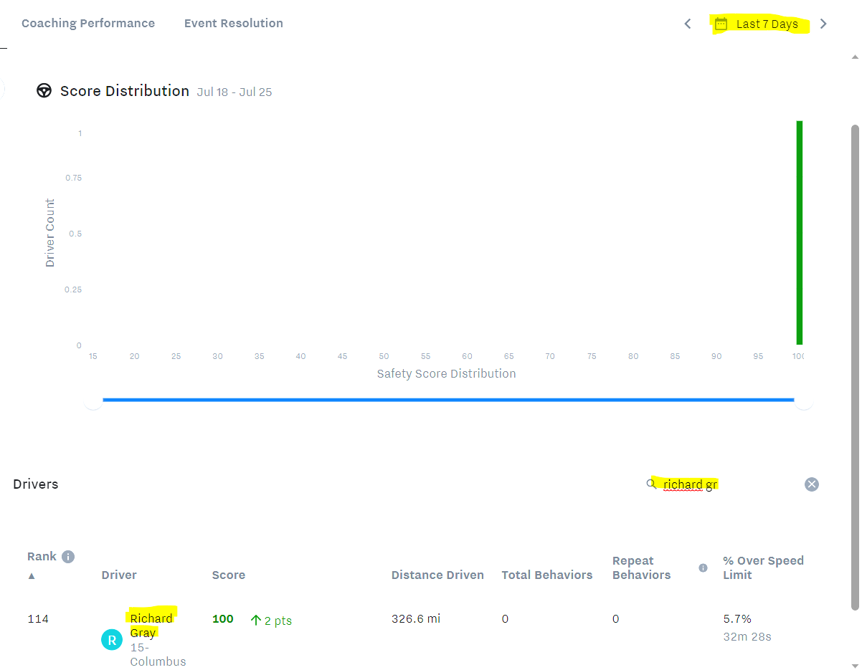
4. Select the time frame you want covered for that driver. It automatically does 30 days, but this is adjusted for the last 7 days for new drivers as they are evaluated on a weekly basis.
5. Record the information from the Driver performance page on Samsara to the score card. This includes the Driver’s name, Safety score, # of harsh events, Speeding Percentage, Miles driven, Time driven.
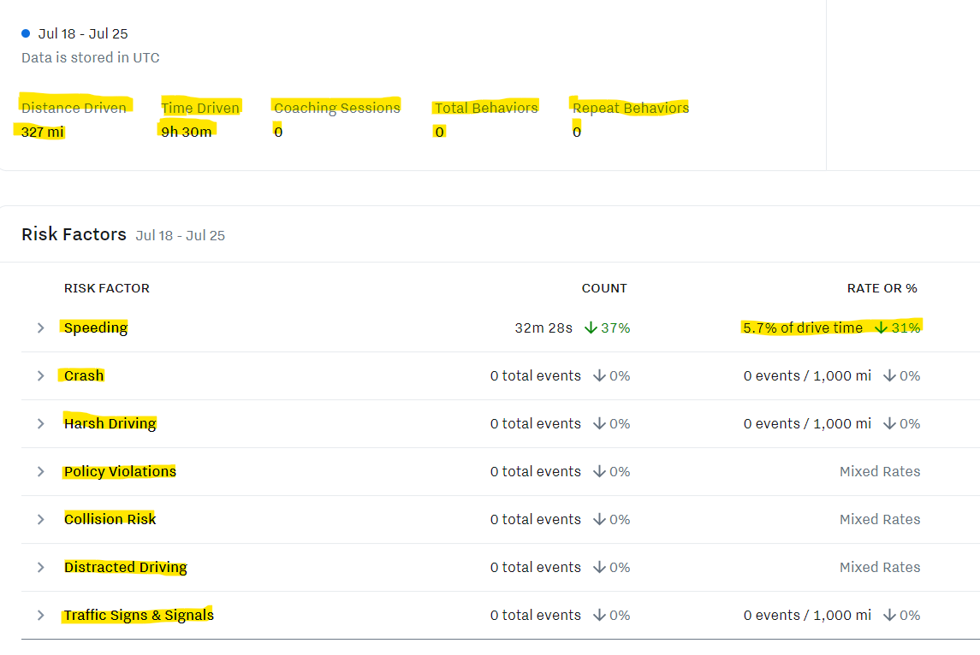
- DVIR Look UP: The number of pre- and post-trip inspections is found under the DVIR section of Samsara.
- This information is located under Samsara/Maintenance/DVIRs (See Pic below).
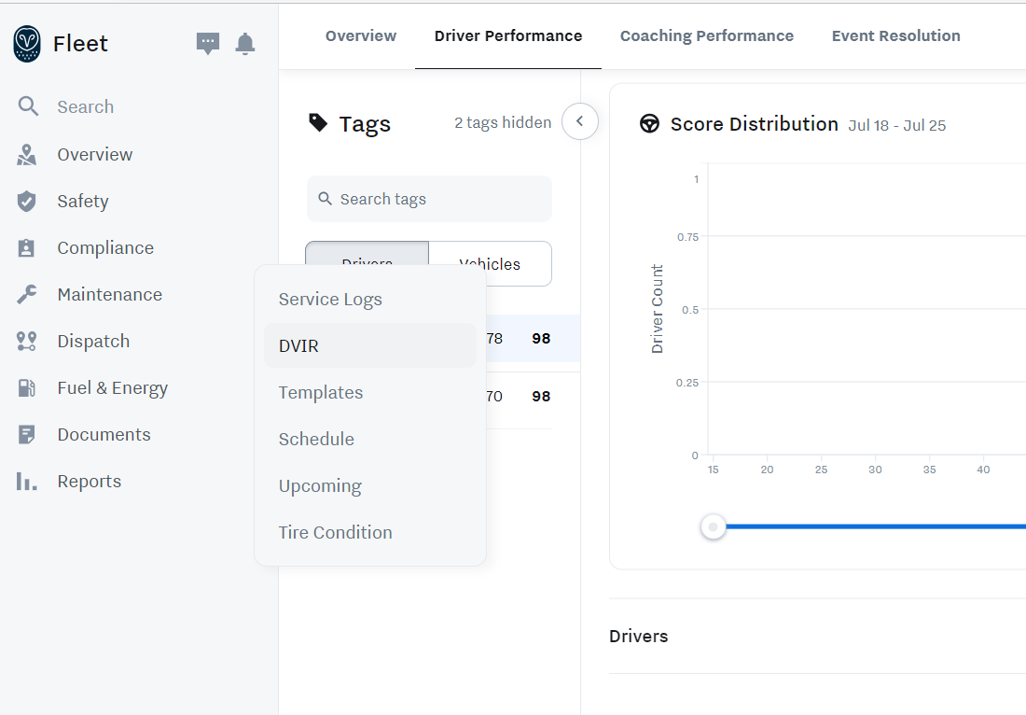
- Look up the driver’s name and time frame to see if the driver did pre- and post-trip inspections on days they drove. The system defaults to DVIRs with defects so it needs changed to see all DVIRs. This is done by selecting DVIRs and All and typing in the driver’s name in the box that sates “Search Inspection Reports)” See example below).

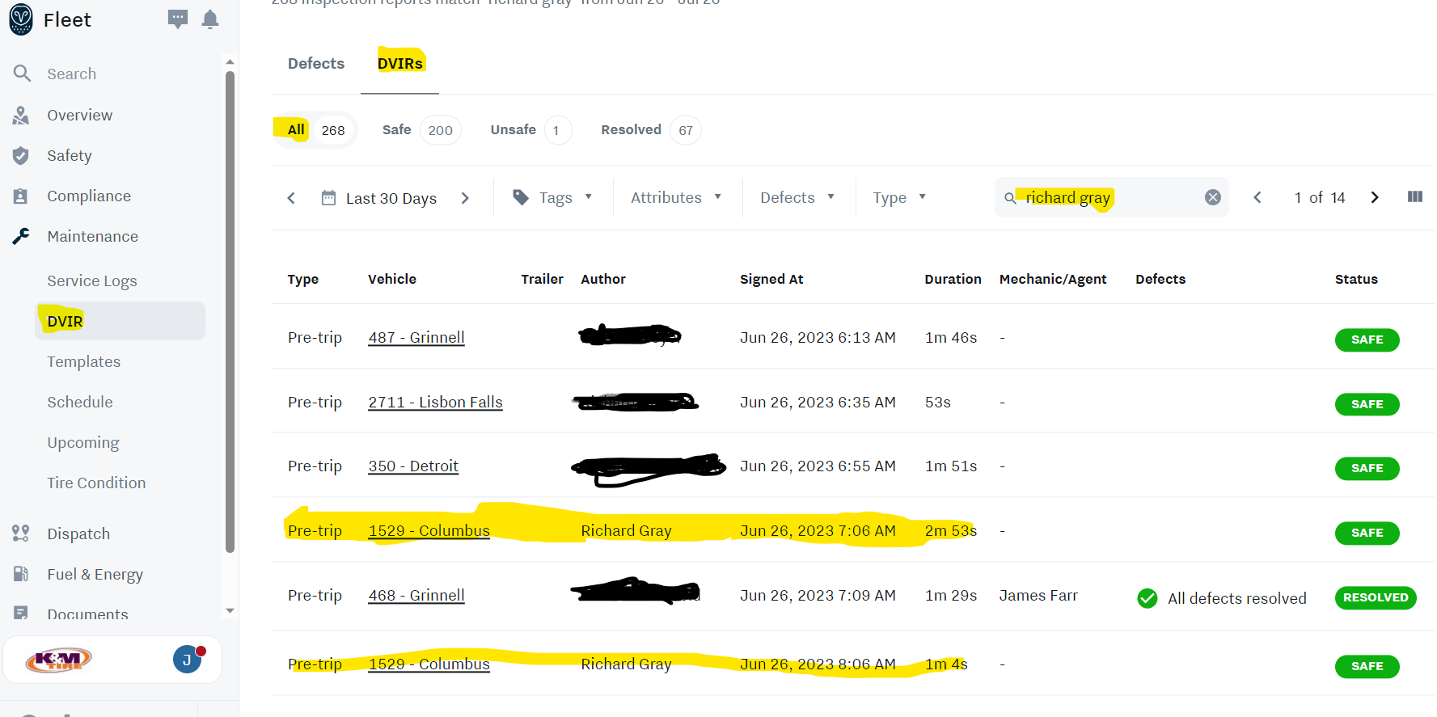

- If you want to research one of the DVIRs, just click on it to bring up the inspection report.

- Take the information gathered from the Samsara Safety page and the DVIR report and record it on the Driver Score card.
- Mark each category as Satisfactory or Needs Improvement and tally the results. The guidelines for Satisfactory performance are as follows.
 |  | Score | Satisfactory | Needs Improvement
Divers Saftey Score |  |  | >97 | 96<
# of Harsh Events |  |  | 0 | 1 or more
Speeding Percentage |  |  | <3% | >3%
# of Inspections |  |  | 2 for each day | any missed
Safety Violations |  |  | 0 | 1 or more
Miles Driven |  |  | Reported miles | Unreported MI
Time Driven |  |  | Reported time | Unreported Time
 |  | Total | 6, 7 | <5

8. The “Other Feedback” section of the Score Card can be used to note trends such as decreased speeding.
9. Mark the Score Card as Satisfactory or Needs Improvement.
10. When the score card is complete, Email the Driver’s score card to their Location Manager and request it to be sent back within a week.
11. File returned and signed score cards under the driver’s name under their location on the Safety Department file. The path to the file is F: drive/ Operations/ Shared/ Safety Department/ Drivers/Audits/Driver Score Cards/Location/Driver
12. Tracking of the turned-in files will be on the New driver Tracking Spreadsheet. The path to the file is F: drive/ Operations/ Shared/ Safety Department/ Drivers/ Audits/ New Driver Tracking Spreadsheet.

Appendix A – Copy of a Driver Score Card
